**Simulation:**

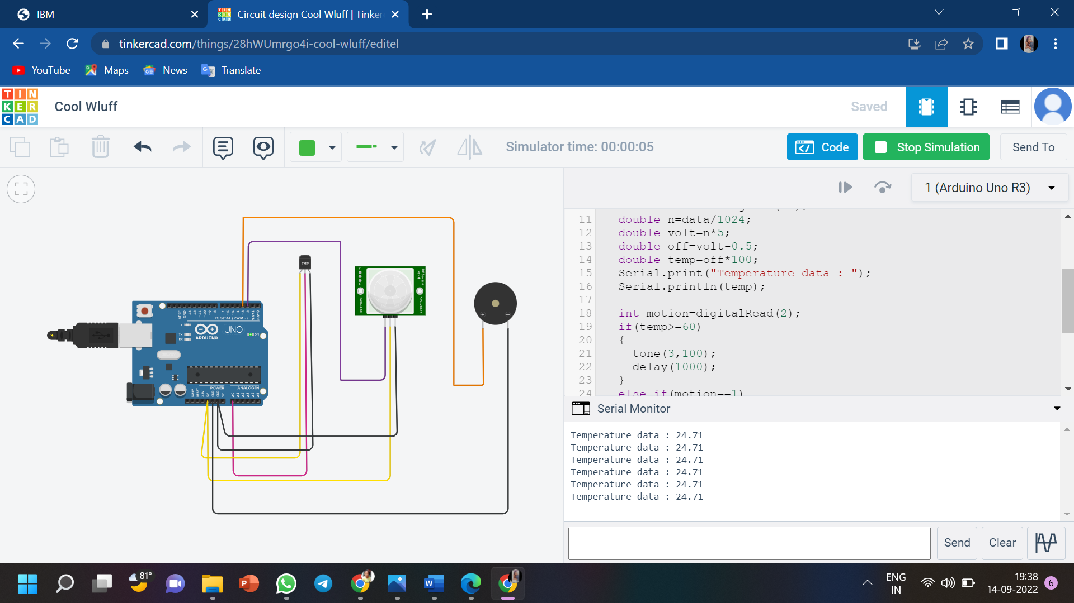

**Code:**

**void setup()**

**{**

**Serial.begin(9600);**

**pinMode(2,INPUT);**

**pinMode(3,OUTPUT);**

**}**

**void loop()**

**{**

**double data=analogRead(A0);**

**double n=data/1024;**

**double volt=n*5;**

**double off=volt-0.5;**

**double temp=off*100;**

**Serial.print("Temperature data : ");**

**Serial.println(temp);**

**int motion=digitalRead(2);**

**if(temp>=60)**

**{**

**tone(3,100);**

**delay(1000);**

**}**

**else if(motion==1)**

**{**

**tone(3,200);**

**delay(1000);**

**}**

**else**

**{**

**noTone(3);**

**delay(1000);**

**}**

**}**